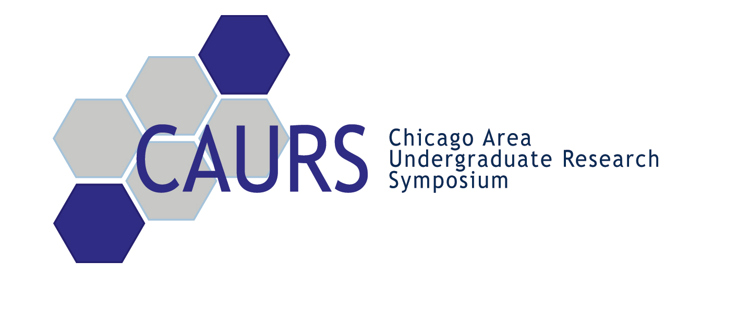

November 9, 2005

Dear ,

My name is Matthew Fishman, and I am a sophomore at Northwestern University. Throughout the past year, groups of students, professors, and administrators from the University of Chicago, Loyola University, the University of Illinois at Chicago, Illinois Institute of Technology, and Northwestern University worked on an initiative to promote undergraduate science research in the Chicago area. Our efforts culminated in a first-of-its-kind research symposium held last April, complete with poster and oral presentations by over 70 undergraduate researchers, professional lectures, a career forum, and a closing awards banquet. President Henry S. Bienen of Northwestern University contributed the symposium’s opening remarks, and Dr. Stephen Rosen, Director of the Lurie Cancer Research Center, gave the keynote address. We are now ready to announce the Second Annual Chicago Area Undergraduate Research Symposium (CAURS) taking place Saturday, April 1, 2006 in downtown Chicago.

I am writing to ask if XYZ Co would be willing to contribute funding for this year’s symposium. For your support, XYZ Co will be able to attend all research presentations and discuss research topics with all participating undergraduates. Sponsors will have the use of an exclusive room, stocked with refreshments, in order to network with all participating and visiting students, faculty, graduate students and other top industry representatives. XYZ Co is additionally encouraged to display company banners, distribute promotional items, and actively recruit students and attendees during the event.

We are very excited about this unique opportunity to promote undergraduate research in science and engineering between five of the top universities in the Chicago area. We hope you will take the opportunity to work with us to make the symposium a great success. The registration form and contact information is included with this email. This year’s symposium schedule is also included, but is still subject to slight alterations as details continue to be finalized. Additional information and updates are available on our website at http://www.caurs.com/.

Thank you for your time and consideration, and please feel free to contact me with any questions that you may have. I can be reached anytime at (952) 270-9219, or by email at
m-fishman2@northwestern.edu.

Sincerely,

Matthew Fishman
(952) 270-9219
m-fishman2@northwestern.edu
CHICAGO AREA UNDERGRADUATE RESEARCH SYMPOSIUM

Saturday, April 1, 2006

Northwestern University
Kellogg School of Management

Registration Form:

Name: __________________________________________________________________
Address: _______________________________________________________________
Phone number: ___________________________________________________________
Company: _______________________________________________________________
Title: ___________________________________________________________________
Email: __________________________________________________________________

I will attend the Undergraduate Research Symposium as a:
__ $50 Participant (inclusion at the day’s activities)
__ $500 Sponsor (Participant’s benefits plus recognized as sponsor on all Symposium materials)
__$1500 Benefactor (Participant’s benefits, plus recognized as Premier Benefactor on all Symposium materials and two seats at awards dinner)
__$5000 Benefactor plus national publicity through the parent “American Undergraduate Research Society”, and travel grants given to students will require them to have your logo on their poster.

Benefactors and Sponsors will be recognized in the Symposium Program only if their registration is received by March 6, 2006.

Method of Payment:

___ Enclosed is a check made payable to “Northwestern University”

___ Please charge my: __ Visa __ MasterCard

____________________________________ __________________
Card number Expiration date

_______________________________________
Signature

Refunds will only be made with written confirmation received before March 25, 2006.

Please print and return this registration form by fax to 847/491-5937 (credit card payment only) or by mailing a check to:
Mr. Joseph Cribari
Department of Chemistry
Northwestern University
2145 Sheridan Road
Evanston, IL 60208
Confirmation emails sent upon receipt of registration. Please call (847/467-3326) with any questions.
SCHEDULE OF EVENTS
Saturday, April 1, 2006

9:00 – 9:50am

10:00 – 10:20am

10:30 – 11:20am

11:30 – 12:50pm

1:00 – 1:50pm

2:00 – 2:50pm

3:00 – 3:50pm

4:00 – 4:50pm

5:00 – 5:50pm

6:00 – 6:30pm

Continental Breakfast/ Registration

Opening Remarks

Oral Presentations Session 1

Lunch/
Career Forum

Poster Presentations
Session 1

Oral Presentations Session 2

Poster Presentations
Session 2

Keynote Speaker

Reception Dinner

Awards Ceremony

